Exercise 1

//App.js

import './App.css'

function App() {

  return (

    <h1>Welcome the firat session of React</h1>

  );

}

export default App;

Output

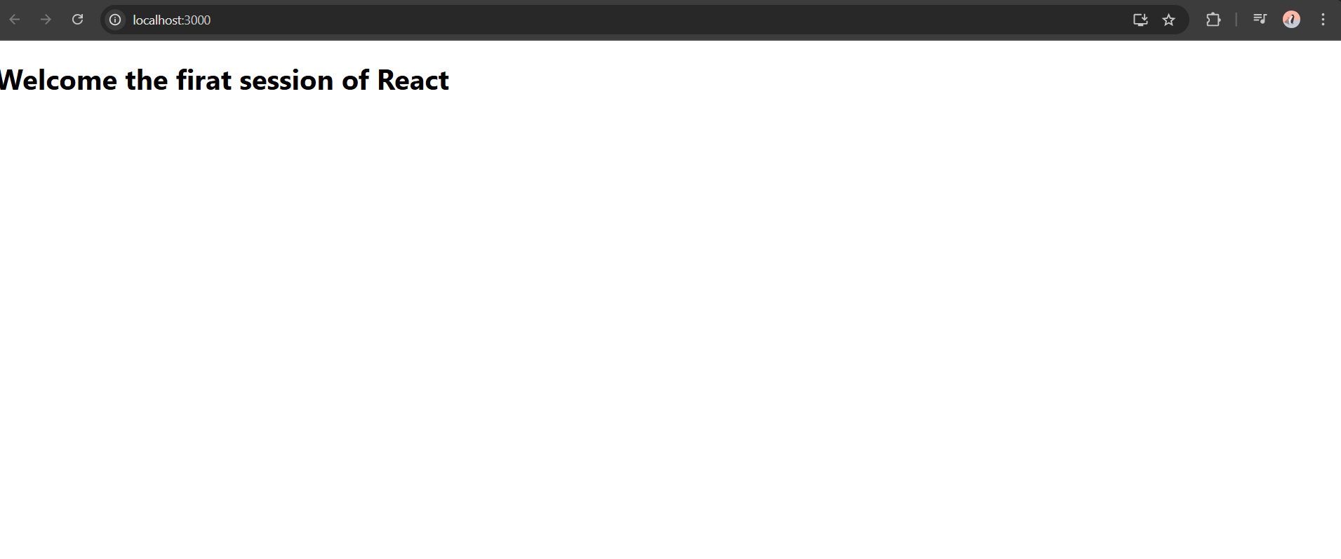

Exercise 2

//About.js

import React, { Component } from "react";

class About extends Component {

  render() {

    return (

      <div>

        <h3>Welcome to the about Page of Student Management Portel</h3>

      </div>

    );

  }

}

export default About;

//Contact.js

import React, { Component } from "react";

class Contact extends Component {

  render() {

    return (

      <div>

        <h3>Welcome to the Contact page of the student Management Portel</h3>

      </div>

    );

  }

}

export default Contact;

//Home.js

import React, { Component } from "react";

class Home extends Component {

  render() {

    return (

      <div>

        <h3>Welcome to Home Page of student Management Portel</h3>

      </div>

    );

  }

}

export default Home;

//App.js

import './App.css';

import Home from './Home';

import About from './About';

import Contact from './Contact';

function App() {

  return (

    <div className="App">

      <Home />

      <About />

      <Contact />

    </div>

  );

}

export default App;

//Output

